**BlinkIT Sales analysis Project (SQL)**

1. Find Total Sales in Millions

Query : select

concat(cast(sum(Sales)/ 1000000 as decimal(10,2)),' Millions') as TotalRevenueInMillions

from blinkit_sales;

Output :

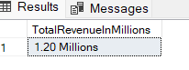

1. Average Sales

Query: select

round(avg(Sales), 2) as AverageSales

from blinkit_sales;

Output :

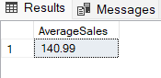

3.Total Items Sold

Query : select

count(Item_Type) as TotalItems

from blinkit_sales

Output :

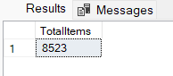

4. Average Rating

Query : Select

round(avg(Rating), 2) as AverageRating

from blinkit_sales;

Output :

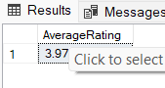

5. Total Sales , Average sales, Average Rating, total Item sold as per fat Content

Query : select Item_Fat_Content,

concat(cast(sum(Sales)/ 1000 as decimal(10,2)),' Thousand') as TotalRevenueInThousand,

round(avg(Sales), 2) as AverageSales ,

count(Item_Type) as TotalItems ,

round(avg(Rating), 2) as AverageRating

from blinkit_sales

group by Item_Fat_Content

order by TotalRevenueInThousand desc;

Output : 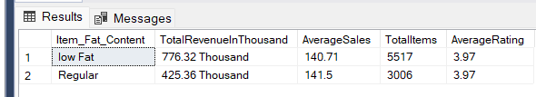

6. Total Sales , Average sales, Average Rating, Number Of items by Item Type

Query : select Item_Type,

concat(cast(sum(Sales)/ 1000 as decimal(10,2)),' Thousand') as TotalRevenueInThousand,

round(avg(Sales), 2) as AverageSales ,

count(Item_Type) as TotalItems ,

round(avg(Rating), 2) as AverageRating

from blinkit_sales

group by Item_Type

order by TotalRevenueInThousand desc;

Output : 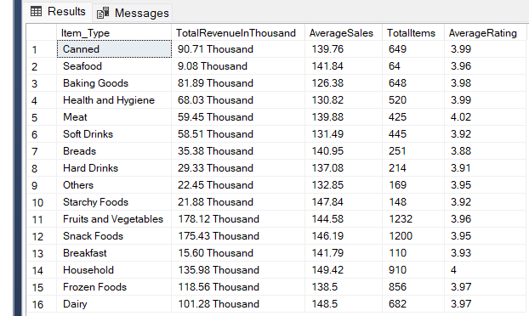

7. Total Sales , Average sales, Average Rating, Number Of items by Outlet Location Type, and item_Fat_Content

Query : select Outlet_Location_Type, Item_Fat_Content ,

concat(cast(sum(Sales)/ 1000 as decimal(10,2)),' Thousand') as TotalRevenueInThousand,

round(avg(Sales), 2) as AverageSales ,

count(Item_Type) as TotalItems ,

round(avg(Rating), 2) as AverageRating

from blinkit_sales

group by Outlet_Location_Type, Item_Fat_Content

order by TotalRevenueInThousand desc;

Output : 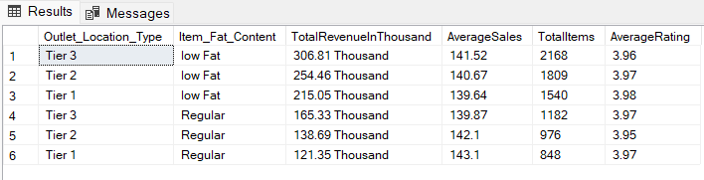

8. Total Sales by outlet establishment year

Query : select Outlet_Establishment_Year,

concat(cast(sum(Sales)/ 1000000 as decimal(10,2)),' Millions') as TotalRevenueInMillions

from blinkit_sales

group by Outlet_Establishment_Year

order by Outlet_Establishment_Year asc;

Output : 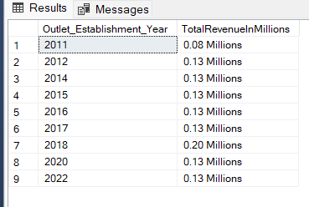

9. Percentage od Sales by Outlet size

Query : select Outlet_Size, round(Sum(Sales), 2) as TotalSales,

round(sum(Sales) * 100 / sum(sum(Sales)) over() , 2) as SalesPercentage

from blinkit_sales

group by Outlet_Size

order by TotalSales desc;

Output :

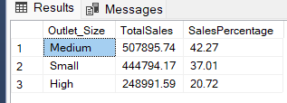

10. Sales by Outlet Location

Query : select Outlet_Location_Type, concat(cast(sum(Sales)/ 1000 as decimal(10,2)),'

Thousand') as TotalSales

from blinkit_sales

group by Outlet_Location_Type order by TotalSales;

Output :

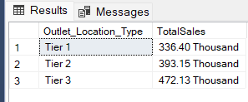

11. All the metrics by outlet type

Query : select Outlet_Type,

concat(cast(sum(Sales)/ 1000 as decimal(10,2)),' Thousand') as TotalRevenueInThousand,

round(avg(Sales), 2) as AverageSales ,

count(Item_Type) as TotalItems ,

round(avg(Rating), 2) as AverageRating

from blinkit_sales

group by Outlet_Type

order by TotalRevenueInThousand desc;

Output : 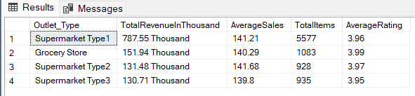

12.